THE CUBAN REVOLUTION
By Dalaney Blottenberger


. Began in 1952 when former army sergeant Fulgencio Batista
seized power
. Batista was president from 1940-1944
. He ran again in 1952
. When he realized he couldn’t win he seized power before
the elections could finish
. Many people infuriated by Batista and his power grab
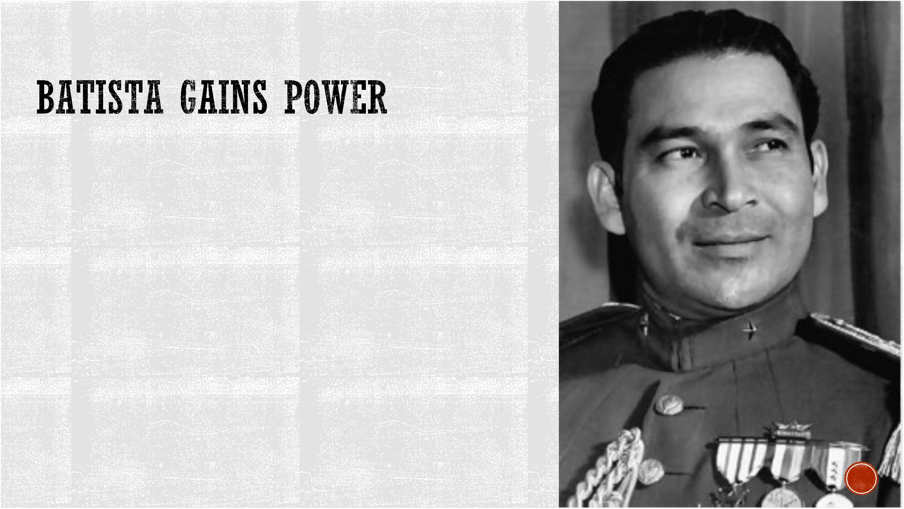

. One particular politician that was extremely vocal about his
disapproval of Batista was Fidel Castro.
. Castro almost immediately began plotting Batista's downfall
. On the morning of July 26, 1953 Castro and 138 other men
attack Moncada.
. The fight was unsuccessful and led to many being captured
or killed.
. Castro escaped but was later caught.
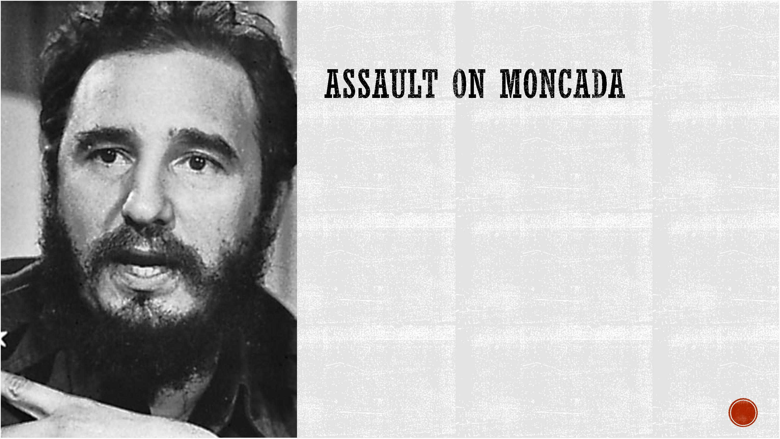

. Castro and the surviving rebels were put on
trial
. Castro was a trained lawyer and managed
to turn the tables on Batista by making the
trial about his dictatorship and power grab
. Castro pled that it was his civil duty as a
loyal Cuban to fight
. Batista's government tried to get him to shut
up by claiming he was too ill to stay on trial
. He was sentenced to fifteen years in prison.
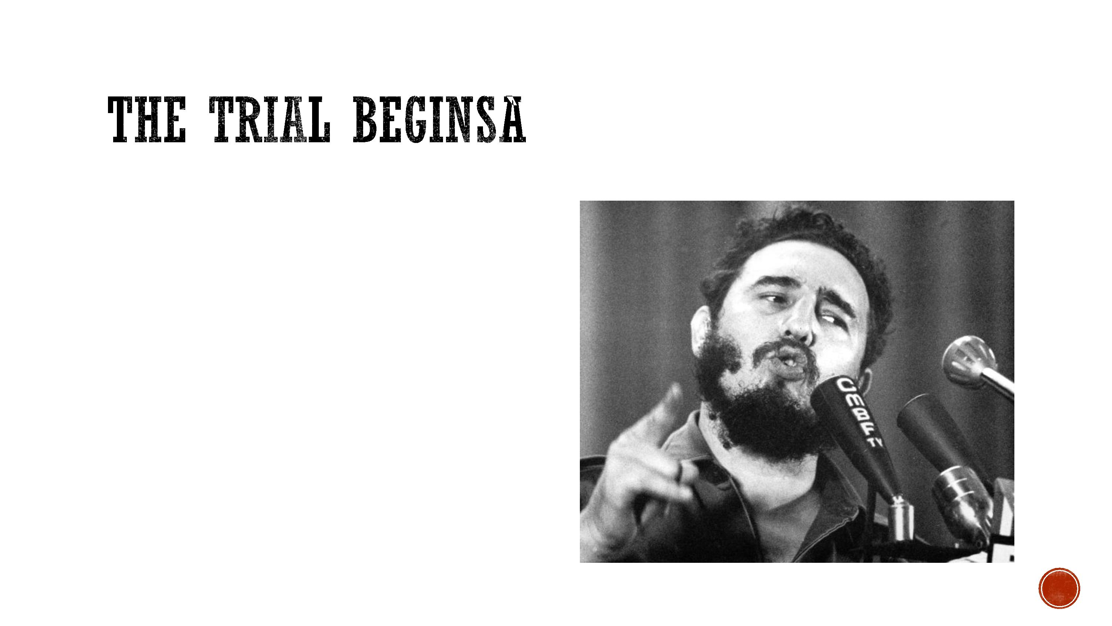

RELEASED
. In May of 1995 Batista's government bent to the urging pressure to reform
. They released many political prisoners including those who took place in the
Moncada Attack
. Fidel left for Mexico in hopes of regrouping and restarting the revolution
. There he gained movement by adding new rebels to his group


HIGHLANDS
. Batista's men had heard of the new threat and ambushed them forcing Castro into
the highlands
. In the highlands the rebels regroup adding more members and more weapons
. As the movement gained power more rebels were added
. Batista decided to send an army into the highlands
. They were brutally beaten by the growing rebels
. By the end of 1958 Castro was ready to make his move

. In late 1958 Castro dived his forces
and made his way into towns
. He was greeted with excitement
. Batista and his inner circle saw that
Castro's win was inevitable and ran
for the hills
. Castro had won.
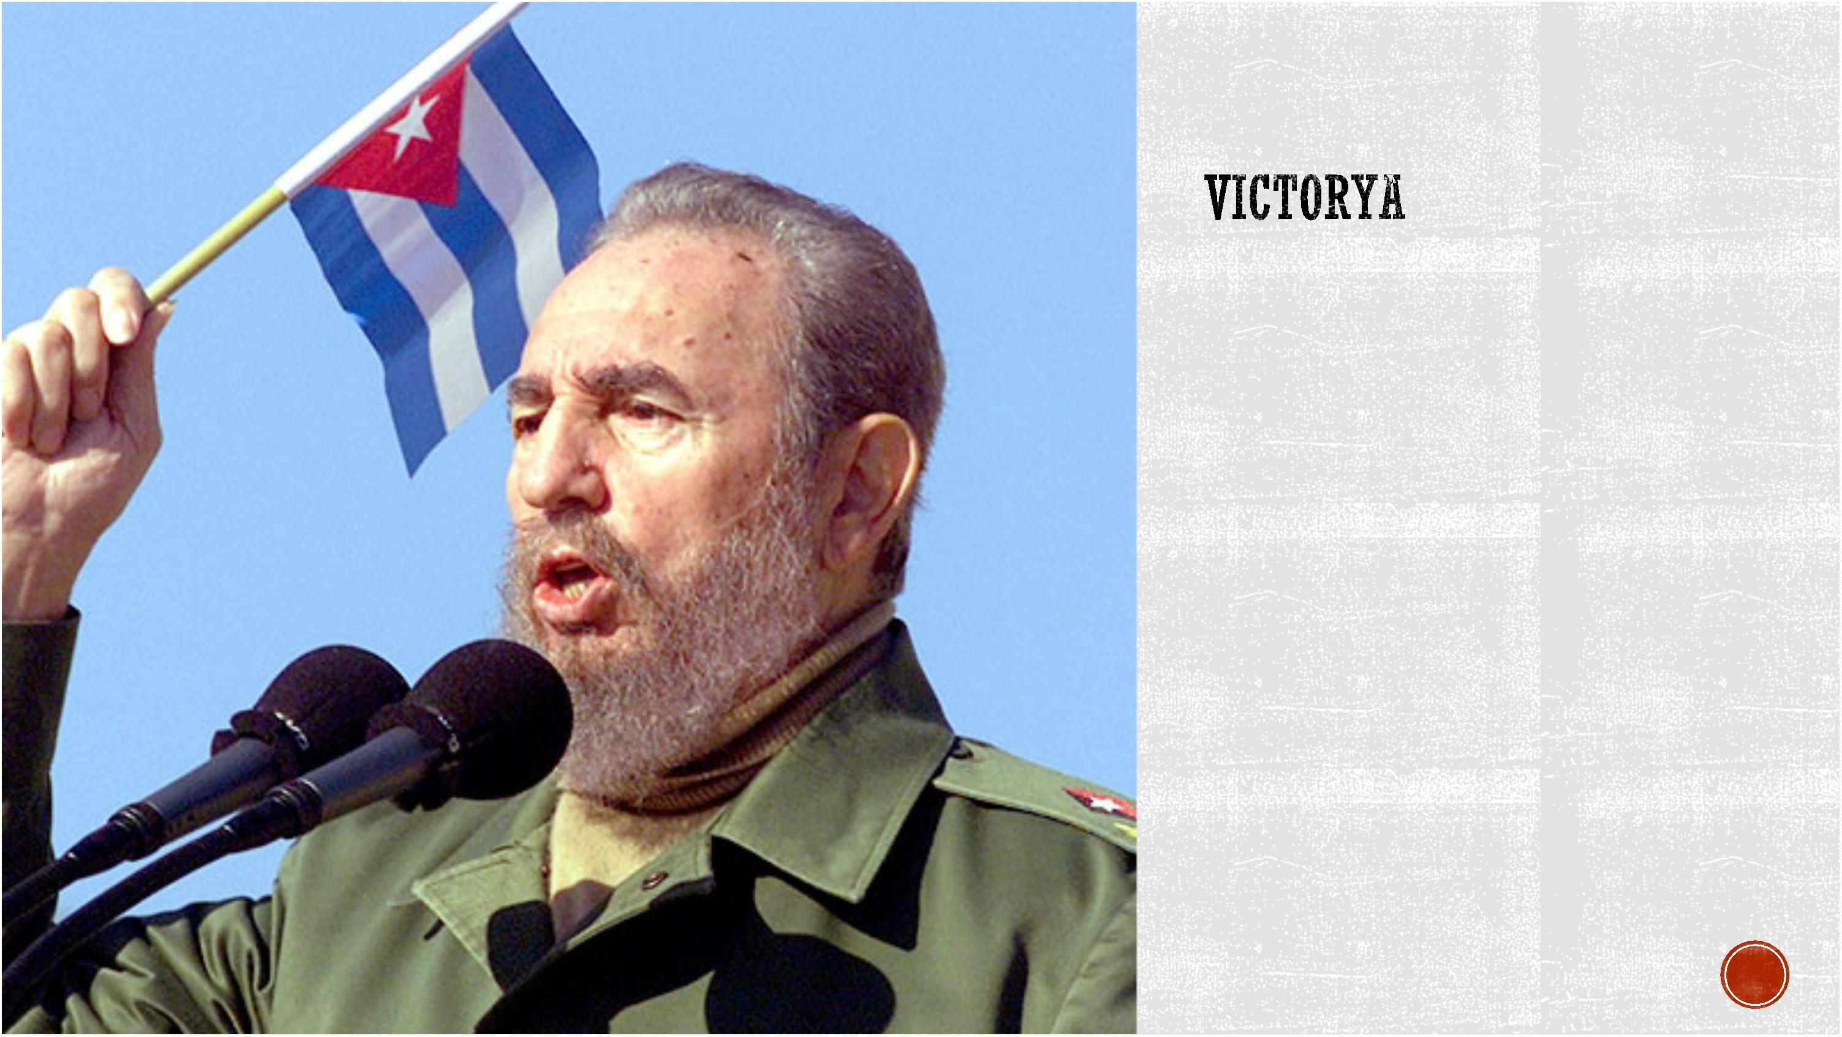

. https://www.washingtonpost.com/world/fidel-castro-cuban-dictator-dies-at-
90/2016/11/26/f37bf3bc-b399-11e6-be1c-
8cec35b1ad25_story.html?utm_term=.47b1ce24db93
. https://www.biography.com/people/fidel-castro-9241487
